## Web Technologies Lab Manual as per JNTUK-R16

**EXPERIMENT-5**

### 5. Design a web page using CSS (Cascading Style Sheets) which includes the following:

1. **Use different font, styles: In the style definition you define how each selector should work (font, color etc.). Then, in the body of your pages, you refer to these selectors to activate the styles.**

**styles.css**

h1

{

color:red;

font-family:caStellar; font-size:22pt;

text-decoration:underline;

}

h2

{

color:blue;

font-family:Chiller; font-size:18pt;

text-decoration:overline;

}

p

{

color:magenta;

font-family:Trebuchet MS; font-size:14pt;

font-style:italic;

}

**fontstyles.html**

<html>

<head>

</head>

<body>

</body>

</html>

<title>Usage of different font,styles and colors </title>

<link rel="stylesheet" type="text/css" href="styles.css"/>

<h1>This header is in red</h1>

<h2>This header is in blue</h2>

<p>This is normal text</p>

**OUTPUT:**

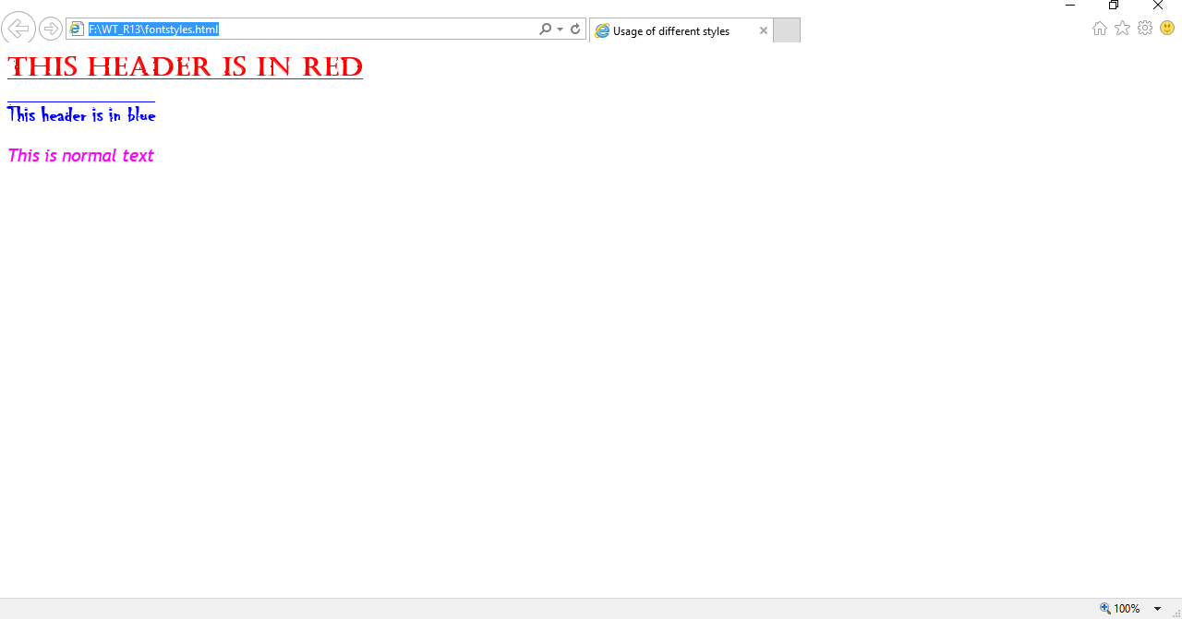

## Web Technologies Lab Manual as per JNTUK-R16

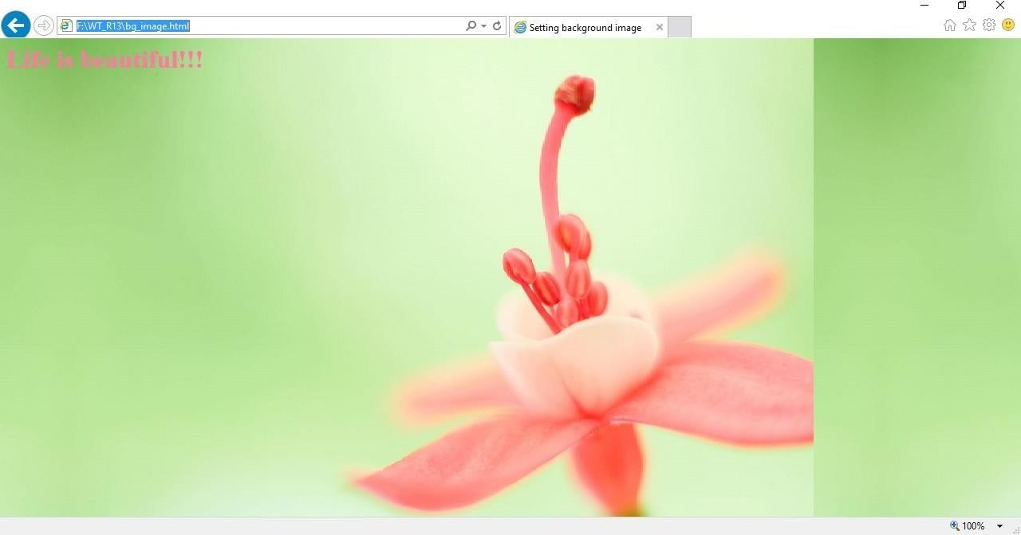

### Set a background image for both the page and single elements on the page.

**bg_image.html**

<html>

<head>

<title>Setting background image</title>

<style type="text/css"> body

{

background-image:url("img11.jpg");

}

</style>

</head>

<body text="#ee78a2">

<h1>Life is beautiful!!!</h1>

</body>

</html>

**OUTPUT:**

## Web Technologies Lab Manual as per JNTUK-R16

### Control the repetition of the image with the background-repeat property.

**bg_repeat.html**

<html>

<head>

<title>Controlling background image</title>

<style type="text/css"> body

{

}

</style>

</head>

background-image:url("img11.jpg"); background-repeat:no-repeat

<body text="#fe78a2">

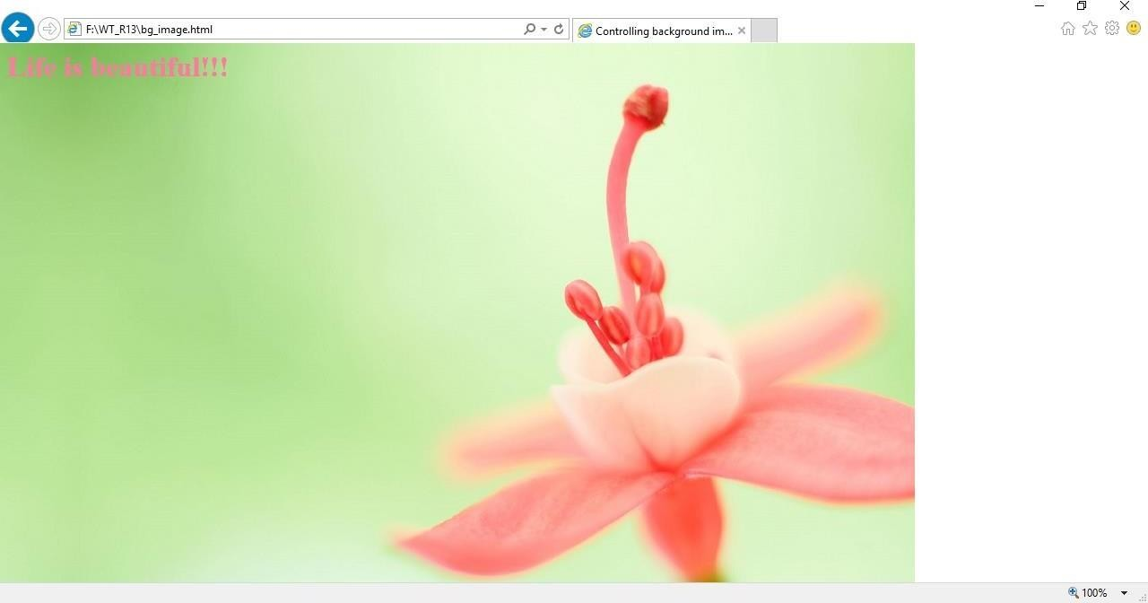

<h1>Life is beautiful!!!</h1>

</body>

</html>

**OUTPUT**